Chapter 11: Phylum Echinodermata

Class Asteroidea

Asterias (Starfish)

The major representative of this class we will use is the starfish Asterias. As with many other echinoderms, it has a radial symmetry based on units of five—pentamerous symmetry—illustrated in this case by the five arms. In addition, echinoderms have a water vascular system which is well illustrated in the starfish.

External Morphology

The starfish has a central disc and five arms called rays. An oral and aboral surface can be recognized. The oral surface is the surface that has a large open mouth in the middle of the central disc and grooves down the middle of each arm. The grooves are called ambulacral grooves and are filled with many soft projections, the suckers of the tube feet. Large spines line the ambulacral groove, and they are used for locomotion.

On the aboral surface, a small and hard-to-see anus is located in the middle of the central disc. A more obvious structure, the madreporite (Fig 11.1), is located on the central disc between two arms. The position of this structure suggests a bilateral symmetry in the starfish. The madreporite is a sieve allowing water to enter the water vascular system.

The surface of the starfish is covered with a ciliated epidermis. Projecting into this layer are numerous blunt spines. The spines are movable and articulate with ossicles, or internal skeletal plates. At the base of the spines is a great deal of soft material. These blunt finger-like projections are known as dermal branchiae, which serve a respiratory and excretory function.

The other structures you should recognize are the pedicellaria (also seen on prepared slides). The pedicellaria are small jaw-like structures on a stalk. The opening and closing of the jaws of these structures keep the surface of the slow moving starfish free of debris and organisms, which otherwise might decide to set up housekeeping on what at first appears to be an immobile object.

The tube feet consist of two parts: the sucker portion is the portion visible in the ambulacral groove. If the ambulacral groove is spread, one can see a small ridge going down the middle of the groove. This ridge is the radial canal of the water vascular system. From this canal, there are lateral canals, which connect the radial canal with each of the tube feet. The lateral canals are very short and run perpendicular to the radial canal. A nerve and blood vessel also run in this ridge. They can be seen best in a cross-section through the arm. On the tips of the arms are some sensory tentacles and a small eyespot, which can be seen with a dissection microscope.

Internal Morphology

With scissors, make a cut through the middle of the aboral body wall of the arm from which you have removed the tip. Cut to within a centimeter of the center of the disc. Make two similar cuts down the side of that arm, so you may be able to remove the aboral body wall from that arm. Observe the inside surface of that wall. The elaborate latticework visibly outline the hard ossicles. They are lined externally with epidermis and internally with parietal peritoneum. Some muscle is present between the ossicles.

The most prominent organs in the arm are two large pale pink masses. These are the pyloric ceca or digestive gland (Fig. 11.1). There is a pyloric duct from each pyloric cecum meeting to form a common duct, which then enters the pyloric stomach. Find this duct, cut it, and remove the pyloric cecum from that arm.

Oral to the pyloric ceca and having a darker pink color and a grape cluster-appearance are the gonads (Fig. 11.1). There are two in each arm. They open to the outside through openings at the junction of each arm.

When the gonads are removed, the ampullae of the tube feet are recognizable as small bulbs on both sides of the ambulacral ridges. The tube foot can be visualized as being constructed something like a medicine dropper, which has both ends closed and has a little canal leaving it just oral to the bulb.
If you follow the ambulacral ridge toward the central disc, you will see two delicate ligaments which go from the sides of the ridge to the cardiac stomach of the organism. These structures are called the cardiac retractor ligaments and serve a unique function. During ingestion of food, a starfish sometimes everts its stomach out through its mouth. These ligaments provide an effective means of returning the stomach to the inside of the body. We have now observed all the organs that are found in the arm, with the exception of those we will see more readily in a cross-section (Fig. 11.2).

The visible organs of the central disc are those of the digestive and the water vascular systems. If you follow the ducts of the pyloric caeca, they lead you to a membranous, collapsed pyloric stomach. If you follow the cardiac retractor ligaments, these structures lead you to a large wrinkled structure, the cardiac stomach, which was oral to the pyloric stomach.

Make a circular cut around the anus one centimeter from the opening. Do not disturb the madreporite. Next, cut off the remainder of the disc aboral body wall, with the exception of the region around the madreporite. Carefully observe the underside of the central portion still attached. You should see a very short, thin rectum, or intestine, attached to the body wall. Two large irregular lobes, the rectal (intestinal) caca, will also be present, and will rest on the pyloric stomach.

The remainder of the digestive system consists of a mouth and esophagus, which leads to the cardiac stomach. The esophagus will be difficult to locate. Surrounding the mouth is the peristomial membrane, which can be seen externally.

We have already noticed and avoided the madreporite. Carefully cut around the structure and through the body wall. You should observe a hard white tube, the stone canal, coursing orally from the madreporite. This canal extends to the mouth region, where it communicates with a circular canal, the ring canal, which runs around the central disc inside of the oral body wall. The axial portion of this canal has swellings, the Tiedemann bodies. This portion of the water vascular system is seen to greater advantage if the axial digestive structures are removed. The radial canals lead from the ring canal (Fig. 11.1).

The starfish uses its water vascular system for locomotion and obtaining food. In both cases, the organ in contact with the environment is the sucker of the tube foot. In locomotion, it can become turgid. More often in locomotion, it is not the rigid aspect that facilitates this function, but rather the ability of the sucker to function as a sucker. Apparently, when the end of the tube foot is touching a surface, the edge makes a firm contact and water is drawn up into the ampulla thus creating a suction effect. This suction is considerable, when one remembers that a starfish can exhaust the adductor muscles of a clam. Visualize the complete water vascular system.

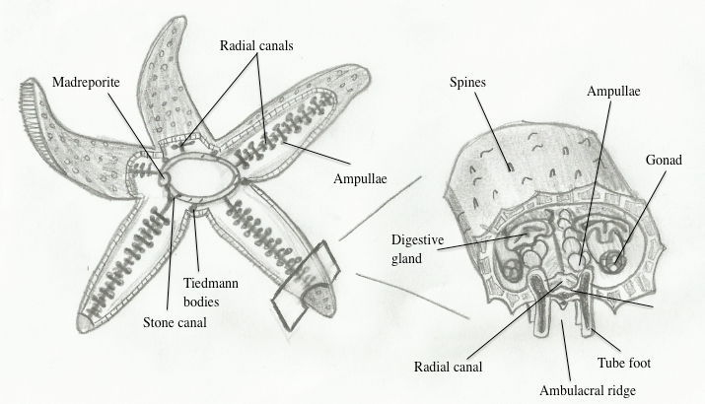
Figure 11.1. Labeled diagrams of starfish internal anatomy.
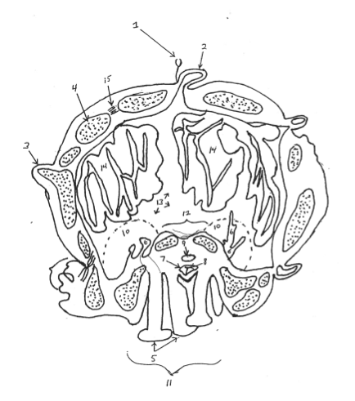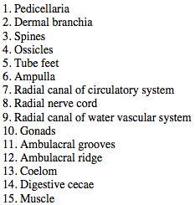

Figure 11.2. Labeled diagram of a cross section through a starfish arm.

Add flows: water vascular and digestive

Other Classes of Echinoderms

Class Ophiuroidea: brittle stars, basket stars
- Arms are segmented—externally, each segment consists of four ossicles —two lateral ossicles with very small spines and oral and aboral ossicles which are spineless. The interior of the arm is almost filled with cylindrical ossicles, which articulate with one another.
- Tube feet without suckers or ampullae. They are small, located laterally on the arms, and appear more like tentacles in shape. Brittle stars use their tube feet for respiration, excretion, and feeding.
- There is an obvious discontinuity between the central disc and arms.
- Ambulacral grooves closed.
- Mouth is star-shaped and surrounded by pentamerous jaws, which are lined with teeth.
- Madreporite oral and in a modified buccal shield—the buccal shield consists of large plates located on the disc between the arms or rays.
- No anus, external genital pores, or pedicellaria.
- Digestive and reproductive structures confined to the central disc.
- Capable of rapid movement.
- Look at the large basket star for characteristics of the class.

Class Echinoidea: sea urchins, sand dollars
- No Arms
- Have pedicellaria
- Closed ambulacral grooves
- Sea urchins
  - Long, moveable spines
  - Podia of tube feet form five rows going from the oral surface to the aboral surface ambulacral areas.
  - Peristomial membrane surrounds the mouth, at outer edge of the lip of the membrane are ten buccal podia.
  - Five pairs of bushy peristomial gills surround the peristomial membrane.
  - Aborally in the center of the body is a circular membrane, the periproct. The opening in the middle of the periproct is the anus.
  - Around the periproct are five pentagonal plates, the genital plates. These plates each have a genital pore on their outer margin. In addition, one of the genital plates is modified to form a madreporite (aboral).
  - Each spine is attached to its associated ossicle through a ball and socket joint.
  - Internal to the mouth is an elaborate set of jaws called Aristotle's lantern. Look at jaws that have been dissected out of a few urchins and are on display.
- Sand dollars
  - Very short oral/aboral axis.
  - Ambulacra are on the aboral side and are petaloid in shape.
  - Tube feet with suckers cover the oral surface and are used for locomotion with the many small spines. Tube feet in the aboral ambulacra do not have suckers and are used in respiration.
  - Radiating ambulacral grooves on oral surface.
  - Madreporite on aboral surface in center of organism and manifested by numerous pores in the central madreporite plate.
  - Genital plates surround the madreporite plate. Four of the genital plates have genital pores associated with them.
  - Lunules—oval holes—go from oral to aboral surface.
  - Anus is aboral and located with periproct axial in the closest lunule to the mouth.
  - Look at plastic mount and small preserved sand dollars.

Class Crinoidea: sea lilies (stalked), sea feathers (not stalked)
- Body of stalk, calyx, and arms. Specimen we have is embedded in plastic and belongs to the genus Antedon. It is an example of a sea feather and is not stalked and is mobile.
- Small root-like objects extend from the crown; they are called cirri. Cirri are made of jointed ossicles with a terminal claw for grasping.
- The crown consists of aboral ossicles (calyx) and a membranous oral surface (tegmen). The tegmen is difficult to see in the plastic mount. The tegmen contains the centrally located mouth. Ambulacral grooves (open) radiate from the mouth towards the arms.
- Five arms leave the crown, but branch at least once shortly after leaving the central disc, producing a minimum of ten arms. The total number of arms always totals a multiple of five.
- Have small branches coming off the arms called pinnules
- Ambulacral grooves continue from the crown into the arms and pinnules. The surfaces of the tube feet and ambulacral grooves are ciliated. Tube feet are used for respiration and creating a current of water toward the mouth.
- Anus at tip of an anal cone, at margin of crown, between two arms. Probably not visible.
- Reproductive organs located in genital pinnules with numerous genital pores.
- Ossicles in arms and pinnules are segmented, as in Ophiuroidea.
- No madreporite.
- Antedon swims about by raising its arms with the pinnules folded in and lowering the arms with the pinnules maximally diverging.

Class Holothuroidea: sea cucumber
- Oral-aboral axis long, no arms.
- Ossicles are microscopic and present even in the tube feet.
- Ambulacral areas (closed ambulacral grooves) poorly defined although oral to aboral lines of tube feet are recognizable.
- Tube feet with suckers on side in contact with the substrate "ventral" but not on "dorsal" side.
- Mouth surrounded by 10-30 long tentacles.
- Madreporite internal and associated with coelom. Not visible.
- Respiratory trees extend from the cloaca of the digestive system into the coelom and are used for respiration and excretion.
- Genital pore located near the mouth.
- Observe preserved specimens.

