Chapter 12: Guppy Slides
Class Actinopterygii
Subclass Neopterygii
Infraclass Teleostei
Superorder Acanthopterygii
Order Cyprinodontiformes
Genus Lebistes
Species Lebistes reticulatus

Introduction

We will begin learning about phylum Chordata with an intensive study of the anatomy of bony fishes, which belong to clade Osteichthyes (“bony fish”). In this clade, we will study serial cross-sections of an entire fish looking first for the phylum characteristics, then the clade characteristics, and finally the general structure of a typical vertebrate. Next week, we will study jaw anatomy and higher chordate taxonomy.
You should study the two perch models and examine various specimens to appreciate the diversity of clade Osteichthyes. The primary focus of this laboratory exercise, however, is on the histology of the guppy, Lebistes reticulatus, which will be used as a representative of basic vertebrate morphology. This laboratory is challenging, since it will test your spatial orientation skills. You will view many cross-sections, and should draw representative sections that display various organs and structures that we will identify. Then, you must try to reconstruct the cross-sections together in your mind in an attempt to place structures in their appropriate location in three-dimensional space. This is difficult, but your goal should be to begin to think in three dimensions so that you can visualize what structures should be located in a cross-section cut at various levels along the anterior-posterior axis of the organism. You should also be aware of the relationships of various structures on the slides. For example, if you see the heart in cross-section, where is it located on the slide? How does this compare with the location of the heart on the models of the fish in the laboratory? By viewing the heart in several sections, what other structures are seen at the level of the heart? What is dorsal to the heart? What is lateral to the heart? Ask yourself similar questions about other structures that you identify.
Each box of slides contains an entire, two-day-old guppy that has been cut serially into 10 micrometer-thick cross-sections. Serial sectioning refers to the fact that all of the sections cut from the organism are mounted onto slides, rather than just representative sections, as you have viewed in other laboratory exercises. These sections are then mounted onto slides such that the first slide contains the most anterior sections of the guppy; each successive slide contains more posterior sections. The slides are read with the label on your left looking at the sections as if they are a page in a book. Thus, the most anterior section of each slide is in the upper left of the first row of sections. The next most posterior section is then to the immediate right of the previous section. Once you have reached the right end of the first row of sections, return to the second row on the left of the slide. It is not possible to give you exact directions for each slide, since there are about twenty sets of slides and they are all somewhat different in orientation and staining intensity. For a section on one set there should be a corresponding section on other sets. You are therefore seeing very similar sections in each set of slides. Each fish will take up four to ten slides. Each slide will have multiple rows of sections, and each row will contain numerous sections. Therefore, each guppy will be represented by about 200 cross-sections that were collected and mounted in the order in which they were cut. It is important to note that not all of these sections will be equally important to you. Do not feel compelled to study every section, as many adjacent sections will be very similar to each other and display only subtle changes; however, some structures will look very different, or will disappear altogether over the course of just a few adjacent sections. Such regions of changes in the relationships of various structures to each other should be noted.
You should begin your study of guppy anatomy by locating the basic characteristics that distinguish members of phylum Chordata, then subphylum Vertebrata, and finally clade Osteichthyes. We will then initiate a detailed examination of the central nervous system followed by a concentration on the basic excretory, circulatory, and digestive systems. Along the way, you will also observe other important structures on our slides that are not a part of the four focal systems. Refer to the models in the laboratory and drawings in this exercise frequently. As this information is not represented in your other texts, you should make efficient use of your time in the laboratory and make representative drawings of the various structures that you see.

Chordate Characteristics

All chordates must have five hallmark structures sometime in their life cycle. In some chordates, these features persist throughout the lifespan of an organism, yet in others, the key structures are present in the embryo but are highly modified or lost by the time the organism attains maturity. Thus, a brief introduction to chordate embryology is warranted at this time.
The first of the key characteristics to appear in the embryos of chordates is the notochord, a rigid, rod-like cylinder of chordamesoderm. The name Chordata means “having a chord”, which refers to a notochord. The notochord is the precursor of an internal skeleton, and will still be quite apparent in the guppy slides. By maturity, however, most bony fishes show little evidence of a notochord because it is largely replaced by the vertebral column. In particular, the more ventral, heavier portion of each vertebra is found where the embryonic notochord was positioned. This corresponds to the body, or centrum, of the vertebra, which will be examined in more detail in the laboratory on the mammalian skeleton. As vertebra develop, they are initially comprised of hyaline cartilage, which is largely replaced by bone in clade Osteichthyes. A second key feature of the chordates is the presence of a dorsal hollow nerve cord, which is formed from neuroectoderm and is the forerunner of the central nervous system: the brain and spinal cord. Note that the dorsal, tubular nerve cord is immediately dorsal to the notochord in the guppy slides. The third primary structures shared by all chordates are pharyngeal pouches. The pharynx develops from endoderm as the most anterior region of the primitive gut or archenteron (“old gut”). The chordate pharynx has evaginations or diverticula, pharyngeal pouches, that develop off of its walls and grow laterally. In most chordates, the ectoderm that overlies the pharynx also begins to invaginate and grow medially, forming pharyngeal grooves. When a pharyngeal pouch meets and fuses with a pharyngeal groove, a pharyngeal slit or gill slit is formed. This is how the gill slits of fishes are formed, which persist throughout life. Between two adjacent pharyngeal slits is a pharyngeal or branchial arch, each of which are paired and contain the supportive skeletal elements of the gill apparatus, skeletal muscles, cranial nerve branches, and an aortic arch that we will examine more closely later. When listing the characteristics of chordates, a post-anal tail is also often present. This just means that the anus is not found at the posterior terminus of the organism (as in the earthworm); thus there is a true region of the body posterior to the anus that is the tail. Fifth and finally, an endostyle or thyroid gland is present in chordates, though it is not a structure that you need to know in the guppy.

Vertebrate Characteristics

Of course, a key characteristic of vertebrates is the formation of a vertebral column, which largely or completely replaces the notochord. As we shall see in a subsequent laboratory, the vertebral column is segmented due to the presence of metamerism. Unlike annelids and arthropods, which show complete metamerism, vertebrates have only an internal metamerism in the trunk of the body. Vertebrates lack septa between metameres; however, metamerism is clearly suggested by the repetition of structures like vertebra, ribs, spinal nerves, intercostal (“between ribs”) blood vessels, and intercostal muscles. Another key characteristic that distinguishes vertebrates from other chordates is the cephalization of the anterior end of the dorsal hollow nerve cord, forming a true brain. As the brain develops, surrounding mesoderm forms the cartilage and then the bones of the skull. Since the brain is large, the portion of the skull that directly encloses the brain is called the cranium or brain case. The cranial cavity thus contains the brain. Actually, in some classifications, the name Craniata (“having a cranium”) rather than Vertebrata (“having vertebrae”) is given to the subphylum. Since the guppies viewed in the slides are still young, the cranium is still made of cartilage at this time. Note the lavender to purple staining of the cartilage matrix. Also, note the scattered chondrocytes (“cartilage cells”) that reside in lacunae (“little lakes”) within the cartilage matrix.
Other vertebrate characteristics include: the presence of an integument comprised of a multilayered epidermis derived from epidermal ectoderm, and a deeper dermis derived from the dermatome portion of the dorsal mesoderm. The dozens of layers of epidermal cells in vertebrates stand in stark contrast to the two-layered epidermis of phylum Chaetognatha (the arrowworms) and the single-layered epidermis of all other animals. Vertebrate skin may contain numerous glands and a variety of cornified or keratinized appendages such as scales, feathers, hair, claws, nails, and hooves. Also, the eucoelom body cavity is typically subdivided in vertebrates. In fishes, we see a separate pericardial cavity that surrounds the heart and is distinct from the remaining pleuroperitoneal cavity. In most amniotes, the lungs will be in separate pleural cavities with the peritoneal cavity containing only abdominal organs. We will examine the typical vertebrate plan in the circulatory system as well as the excretory system of the guppy. Details of both systems will be given later in this exercise.

Basic Characteristics of Clade Osteichthyes, Class Actinopterygii, Subclass Neopterygii, and Infraclass Teleostei

Clade Osteichthyes contains all extant freshwater fishes and most marine fishes. Members of this class have a bony endoskeleton, which distinguishes them from members of class Chondrichthyes, which have a cartilaginous skeleton. Yet, since our guppy slides are from two-day-old specimens, the skeleton is still comprised of cartilage at this stage. Another major difference between bony fishes and most cartilaginous fishes is the presence of an operculum: a bony covering over the gill slits of all of class Osteichthyes, which is absent in subclass Elasmobranchii (sharks, skates, and rays), but present in subclass Holocephali (chimaeras) of class Chondrichthyes. Note the operculum on the models of the adult perch, on specimens of bony fishes and chimaeras, and on the guppy cross-sections, where it is lateral and ventral to the gill slits.
Clade Osteichthyes is traditionally divided into class Actinopterygii (“ray wings” or “ray fins”) and class Sarcopterygii (“muscle fins”). Sarcopterygians are also called lobe-finned fishes since they have a prominent, fleshy lobe at the proximal base of their paired fins. Note the specimen of Protopterus, the African lungfish, in the laboratory. In addition to two other genera of lungfishes, the only other extant sarcopterygian is the coelacanth, Latimeria chalumnae. We will discuss more of their characteristics in class. Most bony fishes are actinopterygians since they have slender fin rays that support their membranous fins. Unlike lampreys and hagfish, members of clade Osteichthyes have jaws, thus they are gnathostomes (“jaw mouth”). Most bony fishes also posses a gas-filled swim bladder that is important in maintaining buoyancy. The swim bladder may be attached to the pharynx by a pneumatic duct or it may be ductless, with no connection to the gut. On the models of the perch and on the guppy slides, the swim bladder can be seen as a large, hollow structure in the dorsal portion of the posterior peritoneal cavity.
The skin of the first vertebrates had a tendency to form bony plates in the dermis, so-called dermal bone. While the first vertebrates, which were jawless fishes, had heavy dermal plates of bone that developed in their skin like plates of armor, dermal bone has diminished over time as fishes have evolved. The various scales that cover modern fishes are derivatives of the first dermal bony plates. Most modern members of the Osteichthyes have an outer epidermis covered by scales, although some bony fishes like catfish lack scales altogether. When covered by scales, teleosts have either cycloid (Fig. 12.1A) or ctenoid (Fig. 121B) scales. Both kinds of scales are comprised of a thin layer of acellular bone that overlies a much thicker layer of collagen. Thus, cycloid and ctenoid scales are translucent and flexible. Our laboratory contains prepared slides of whole mounts of cycloid and ctenoid scales. Note the rings in both kinds of scales, which represent seasons of growth in the fish.

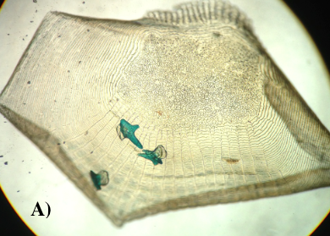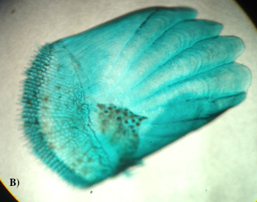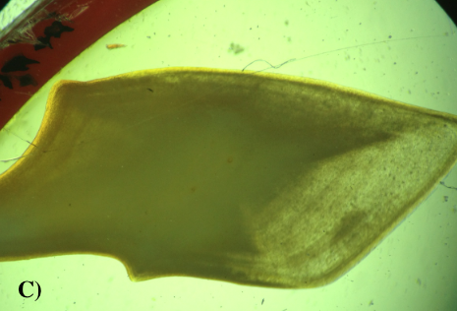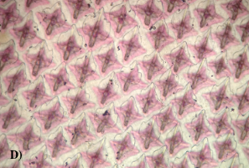

Figure 12.1. Scale types: A. Cycloid B. Ctenoid C. Ganoid D. Placoid

Also look at slides of ganoid scales (Fig. 12.1C), which are found in some members of subclass Chondrostei and infraclass Holostei—fish less modified than teleosts. Ganoid scales are especially abundant on the gars, which can be seen in the laboratory. Moreover, be sure to view slides of the distinctive placoid scales (Fig. 12.1D), which are found only in the sharks in subclass Elasmobranchii of class Chondrichthyes. Ganoid and placoid scales contain a much thicker matrix of bone, which is covered externally by a layer of enamel. Placoid scales are like teeth: they are comprised of an enamel coating that overlies a dentin layer of bone that, in turn, surrounds a hollow pulp cavity which contains blood vessels. Placoid scales have elevated papillae that cause the skin of sharks to feel like sandpaper. In fact, shark teeth are large, modified placoid scales.

Study of the Guppy Slides

Nervous system

The cephalization of the dorsal, tubular nerve cord results in the initial formation of three primary brain vesicles. From anterior to posterior, these are the prosencephalon (“before brain”) or embryonic forebrain, the mesencephalon (“middle brain”) or embryonic midbrain, and the rhombencephalon (“rhombus brain”) since its cavity initially has a rhombus or diamond shape when viewed from a dorsal perspective) or embryonic hindbrain. The primary brain vesicles continue to develop and are modified as five secondary brain vesicles. The prosencephalon develops into an anterior telencephalon (“end brain”) and a more posterior diencephalon (“second brain”). The mesencephalon remains rather small and unchanged, while the rhombencephalon becomes the metencephalon (“after brain”) anteriorly and the larger myelencephalon (“marrow brain” since it connects to the spinal cord, which can be viewed as the marrow of the vertebral column) posteriorly. These secondary brain vesicles are apparent in the guppy and persist into adulthood in all vertebrates. The brain vesicles refer to the walls of the old dorsal, tubular nerve cord which give rise to brain neurons and glia. The neurocoel, or lumen of the nerve cord, contains the cerebrospinal fluid (CSF), and will eventually become the ventricular system of the brain. Cerebrospinal fluid has a composition that is similar to blood plasma. This fluid nourishes, bathes, and protects the brain, and is continuously secreted by the ependymal cells that line the lumen of the central nervous system. Large concentrated tufts of ependymal cells develop in the roof of each ventricle; these regions are called the choroid plexus and thus make a majority of the cerebrospinal fluid. We will not see much evidence of choroid plexus in the guppy slides.

In the mature brain, the lateral ventricles (ventricles I and II) will be in the telencephalon, and the third ventricle (ventricle III) will be in the diencephalon. Moreover, the fourth ventricle (ventricle IV) lies between the dorsally-positioned metencephalon and the ventrally-positioned myelencephalon, and is continued in the spinal cord as the narrow central canal. The third and fourth ventricles are connected by the cerebral aqueduct (of Sylvius). In the guppy slides, only the fourth ventricle and central canal are readily apparent. There is an occasional glimpse of the third ventricle and the cerebral aqueduct in some slides, although this is rare.
Rather than beginning with section one of the first slide, find a cross-section in a set of guppy slides that shows the anterior end of the brain. This will be a good starting place to gain orientation for study of the central nervous system. You will probably see the large pair of eyes at this position along the longitudinal axis of the guppy. In the most anterior end of the brain, the telencephalon is subdivided into four solid, elliptical structures. Dorsally, the larger pair of structures are the hemispheres of the cerebrum (Fig. 12.2). This portion of the brain is where some memories are stored, and it is directly related to intelligence and complex thought processes; it is relatively small in fishes. Ventrally, the smaller pair of structures is the olfactory lobes, which process information for the special sense of smell (Fig. 12.2). Look at the three-dimensional drawing of a fish brain to get an idea of where the cross-section that you are viewing has been cut.

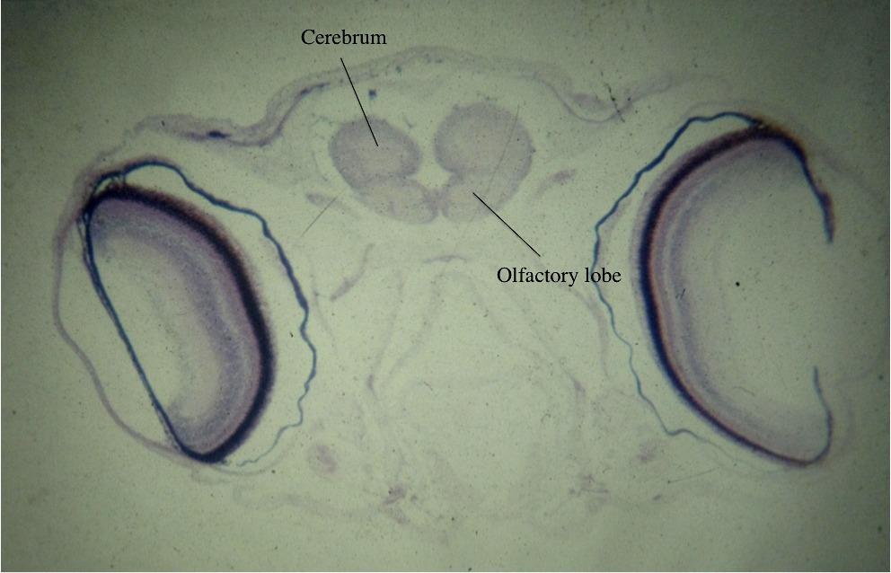

Figure 12.2. Olfactory lobe and cerebrum of the guppy.

Notice on the drawing the anterior projections that attach to each olfactory lobe. These structures are also part of the olfactory portion of the brain, yet they are more difficult to see in the cross-sections. Examine the olfactory lobes with the high-dry objective of your microscope. Look at the ventrolateral aspect of each lobe to see the slender olfactory tract enter each olfactory lobe (Fig. 12.3).

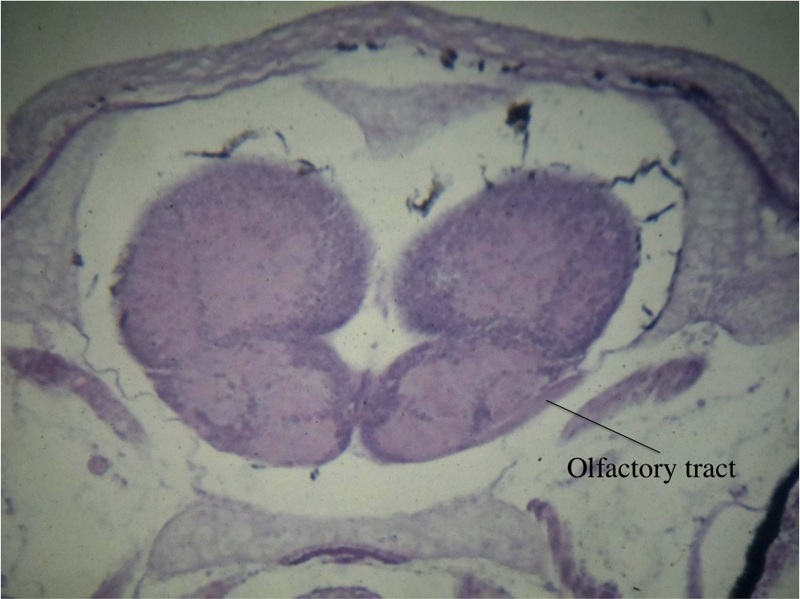

Figure 12.3. Olfactory tract of the guppy.

Then, scroll through the serial sections in an anterior direction, which is opposite the direction of the propagation of the neural impulses. As you do, note where each olfactory tract enters the cranium through an opening in the skull called a foramen (Fig. 12.4).

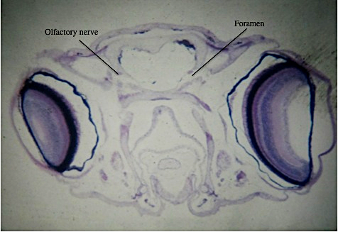

Figure 12.4. Olfactory nerve and foramen of the guppy.

Continue to trace each olfactory tract back to its point of origin, which is a cup-shaped olfactory bulb. The thickened olfactory bulb partially encloses the adjacent olfactory sac (Fig 12.5). The olfactory sac is a diverticulum off of the nasal passages that contains the olfactory epithelium with its olfactory receptors for the sense of smell.

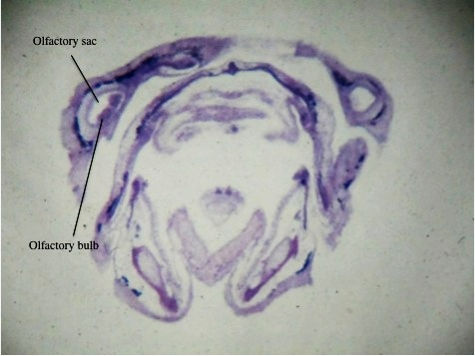

Figure 12.5. Olfactory bulb and olfactory sac of a guppy.

Remember, that we have been tracing the olfactory pathway backwards so far. Essentially, olfaction is a three-neuron pathway. The first-order neuron is the olfactory receptor in the olfactory sac and is outside the brain. Its dendrite is specially-modified for the detection of certain chemicals. When a neural impulse is generated in the olfactory epithelium, the axons of the first-order neurons travel a very short distance to synapse with the short dendrites of the second-order neurons in the olfactory bulb, which is the most anterior end of the brain. The axons of the olfactory receptors collectively comprise the olfactory nerves, the first of the cranial nerves that are outside the brain. Even though we usually talk of a pair of olfactory nerves in all vertebrates, this is technically incorrect, since the axons are not bundled together. Instead, they form many fine connections called the filia olfactoria (“olfactory filaments”). The second-order neurons have their somata in the olfactory bulb; moreover, their dendrites bundled together comprise the two olfactory tracts. A second synapse occurs with the axons and somata of third-order neurons in the olfactory lobe where the chemical information is processed as a smell.
Now, return to a section through the middle of the telencephalon. As you scroll through the serial sections in a posterior direction, note how the boundaries between the cerebral hemispheres and the olfactory lobes become harder to discern. In cross-section, the brain should resemble a rounded-edged triangle with its apex directed ventrally. Note the staining of the brain: much of it appears pale lavender, with some dark purple cells. The paler regions are the white matter that is comprised of neuronal processes like axons and dendrites (Fig. 12.6). In a fresh brain, white matter is colored white due to the presence of myelin, a lipid produced within some glial cells. Glial cell processes then elongate and wrap around axons and dendrites to help increase the velocity by which neural impulses travel.
The large purple cells are the cell bodies, or somata, of neurons; these regions appear darker in a fresh brain and are called the gray matter (Fig. 12.6). Glial cell bodies will also stain purple, yet they are much smaller than neuronal cell bodies and are present everywhere, including in the white matter. Clusters of neuronal somata in the central nervous system are called nuclei while bundles of neuronal processes in the central nervous system are called tracts.

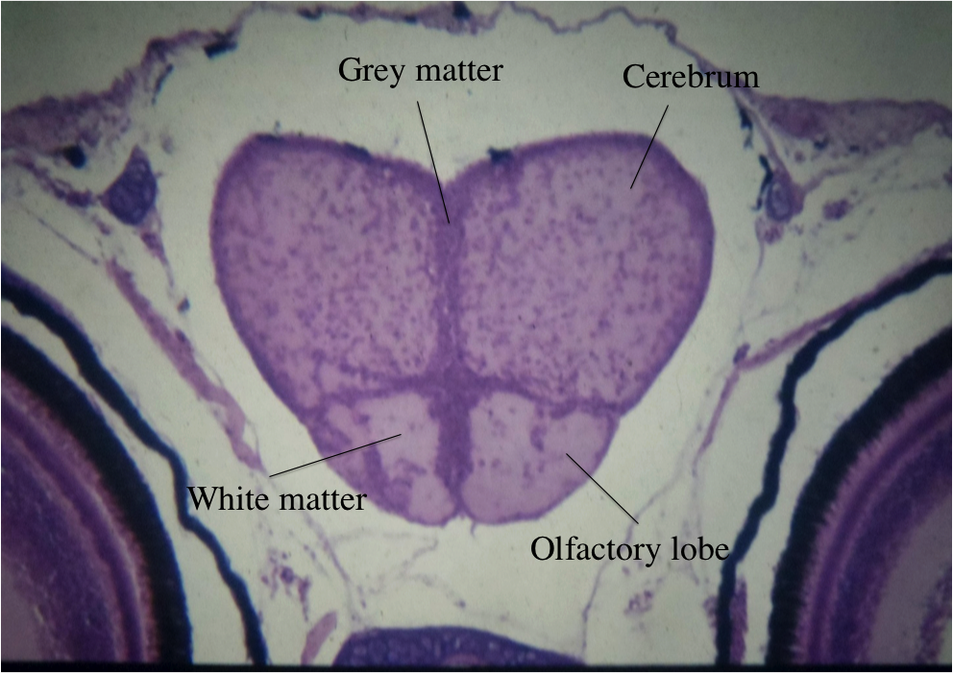

Figure 12.6. White matter and grey matter.

As you move posteriorly from the anterior end of the guppy brain, you are still in the telencephalon as long as you can see a cruciate pattern of nuclei, which divides the telencephalon into four quadrants. When this pattern disappears, you have entered the diencephalon. The diencephalon can be divided into several portions. The larger, more dorsal part of the diencephalon is the thalamus (Fig. 12.7), which is a region where ascending, sensory pathways synapse before entering the cerebrum. Actually, there are two thalami on either side of the third ventricle. The two thalami are visible in the guppy slides, but only rarely can the third ventricle be discerned between them. Let your laboratory instructor or one of the laboratory assistants know if you think that you have found the third ventricle.
On the lateral aspects of the diencephalon, about two-thirds of the way from the dorsal most portion of each thalamus is a small, bilateral indentation called the hypothalamic sulcus, which often contains a small blood vessel. This is the external division between the thalamus, which is dorsal to the sulcus and the hypothalamus (Fig. 12.7), which is ventral to the sulcus. The hypothalamus is rather large in a fish, and is the region of the brain that controls instinctive behaviors like thirst, hunger, aggression, and mating.

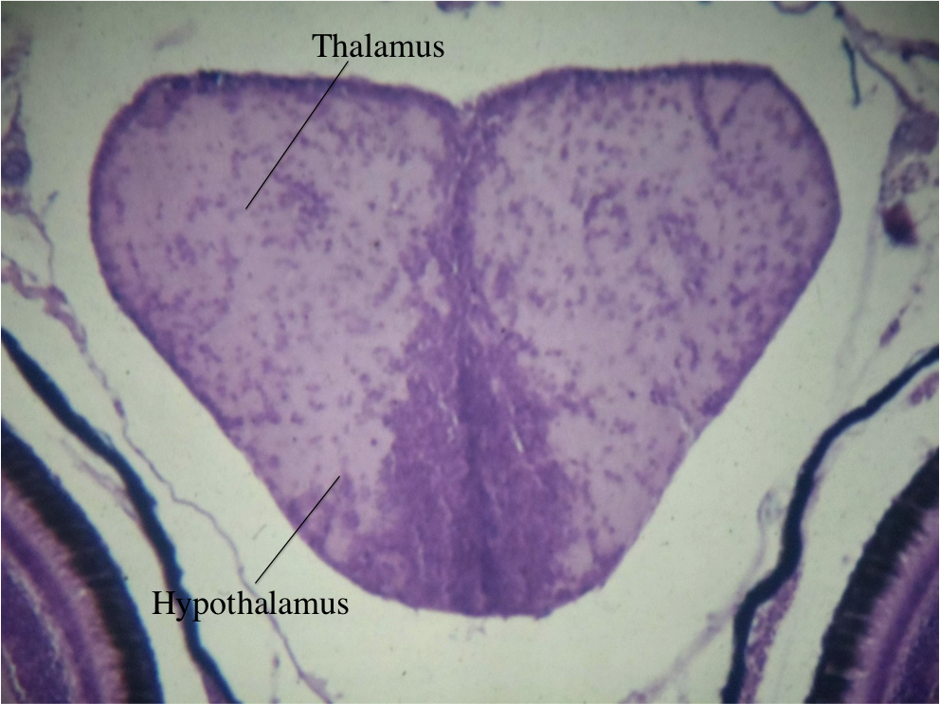

Figure 12.7. Hypothalamus and thalamus of a guppy.

As you continue to move posteriorly in the serial sections, note the unpaired pineal gland or epiphysis (Fig. 12.8), which is in the midline dorsal to the thalami. The pineal gland contains some light-sensitive photoreceptors and thus, regulates the organism's photoperiod or light-dark cycle. This establishes a diurnal, or Circadian, rhythm in many organisms as the photoperiod is built around a 24-hour day. The pineal gland is an endocrine (ductless) gland that also produces melatonin that helps regulate sleep.

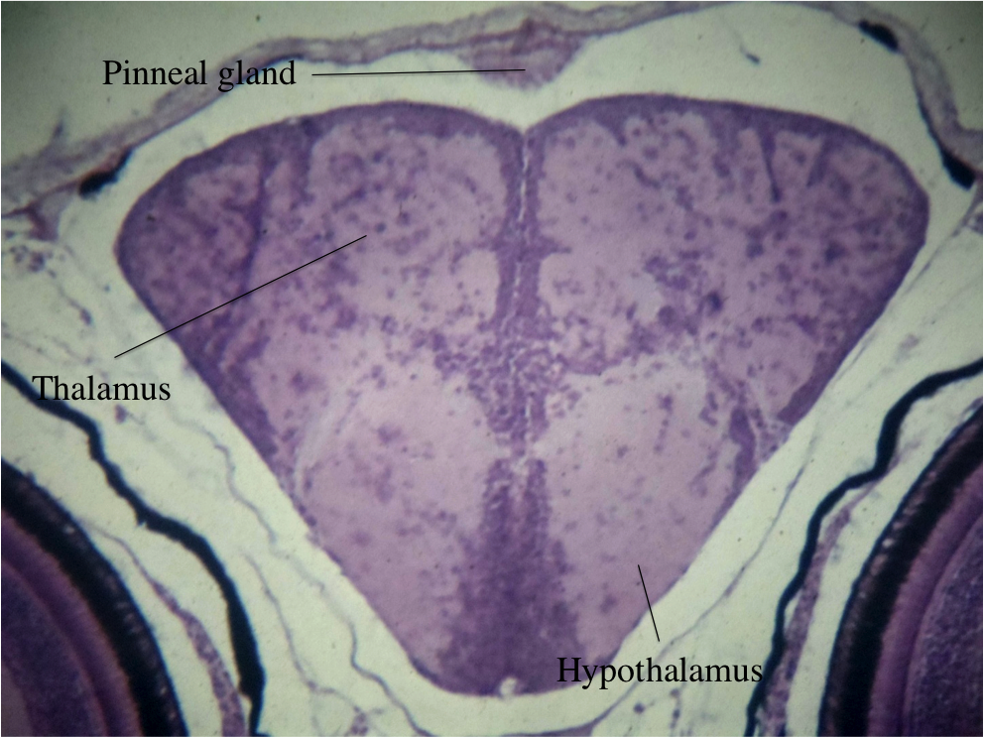

Figure 12.8. Pineal gland, or epiphysis, of a guppy.

Soon after reaching the pineal gland, pay particular attention to the eye and note the optic nerve that arises from the medial surface of each eye. The optic nerves run dorsomedially and touch at a point called the optic chiasm, which is immediately ventral to the hypothalamus (Fig. 12.9). The term chiasm is derived from a Greek word that denotes a shape like an X. Like an X, the two optic nerves converge ventromedially at the optic chiasm, while the two optic tracts diverge dorsolaterally from the optic chiasm (Fig. 12.9). Examine this region at high power and note that most optic nerve fibers cross the midline at the optic chiasm, and then continue as the optic tract on the opposite side of the brain. There are no synapses at the optic chiasm, as the axons pass from the optic nerve into the optic tract and later reach their synapses in the optic lobe: a paired dorsolateral structure which is a part of the mesencephalon and is deep to the distal end of the optic tract (Fig. 12.9).
In the guppy, the optic lobes are comprised of a thick layer of white matter that overlies an equally thick layer of neuronal somata. In fishes, visual information is processed in the optic lobes; in mammals, this occurs in the visual cortex of the cerebrum, which will grow to be much larger than it is in fishes. The crossing of the midline by optic nerve fibers at the optic chiasm is a prime example of a decussation, a name given to where a tract of axons crosses the midline in the central nervous system. Since probably 95 percent or more of the optic nerve fibers decussate at the optic chiasm, these axons can also be called contralateral ("opposite side") fibers or a contralateral projection. The minority of optic nerve axons that do not decussate at the optic nerve are called ipsilateral ("same side") fibers. These axons stay on the same side of the midline as they continue into the optic tract to synapse in the optic lobe on the same side as the eye from which they originate.

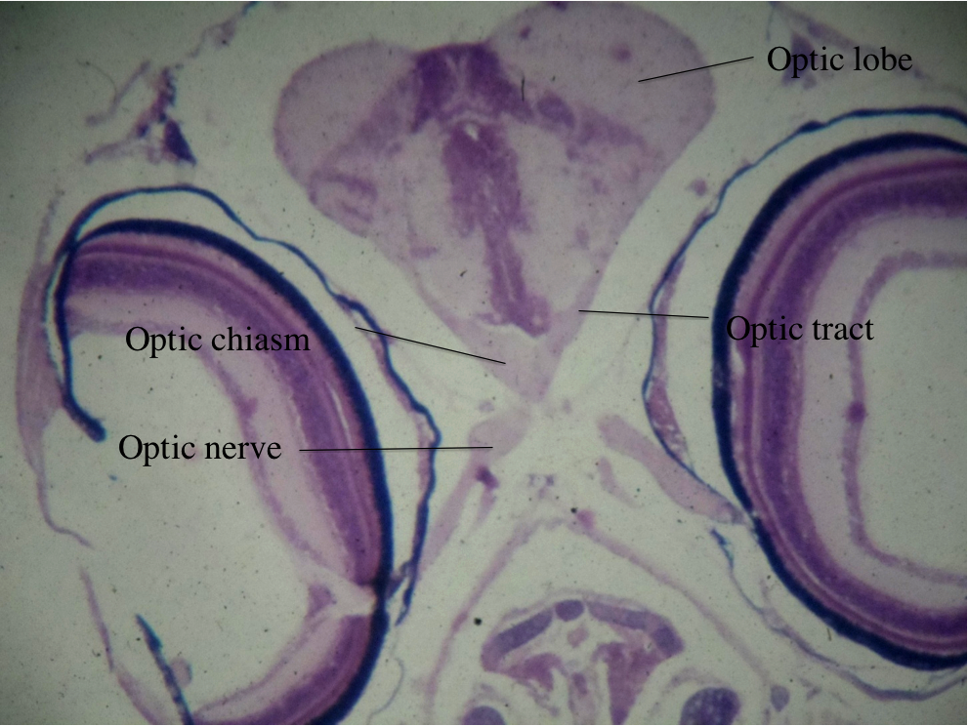

Figure 12.9. Optical structures of the guppy brain.

Posterior to the optic chiasm, the hypothalamus of the diencephalon will give rise to a narrow stalk, called the infundibulum since it is funnel-shaped (Fig. 12.10). In cross-section, the infundibulum will be the ventral most area that protrudes from the hypothalamus on the midline. The infundibulum directly connects the hypothalamus to the pituitary gland, or the hypophysis, the so-called master gland of the vertebrate body (Fig. 12.11). The pituitary gland has received this name because its diverse endocrine hormones control the production of other hormones and secretions in various vertebrate organs, ranging from the thyroid gland to the gonads and many others. It is important to note that the pituitary gland is itself controlled by secretions, called releasing factors or releasing hormones, which are produced by the adjacent hypothalamus.

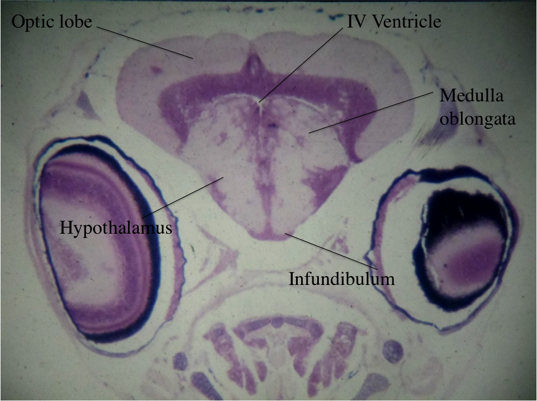

Figure 12.10. Infundibulum of the guppy.
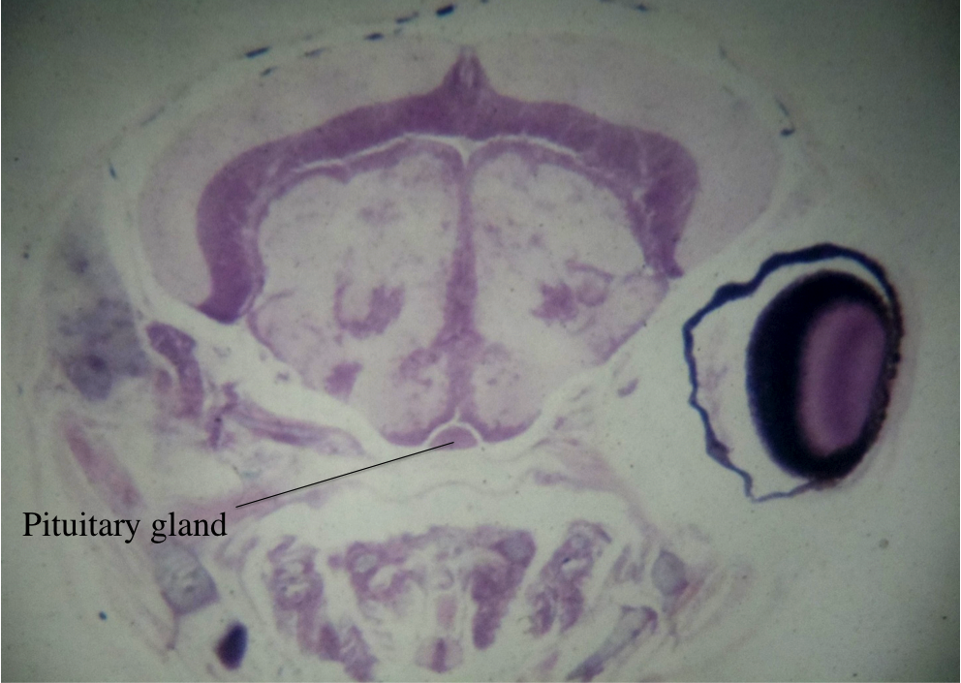

Figure 12.11. Pituitary gland of the guppy.
As you continue to scan posteriorly though the serial sections, the pituitary gland will disappear. In its approximate place, you will eventually see the most posterior structures in the diencephalon, which are the paired, wedge-shaped mammillary bodies (Fig. 12.12). They are named for their surface resemblance to a small pair of breasts. The mammillary bodies are a part of the limbic system, which regulates emotions in the brain.
By the time that you reach the mammillary bodies, you have seen the thalami disappear and be replaced by the medulla oblongata of the myelencephalon (Fig. 12.12). The medulla oblongata controls many of the automatic or involuntary actions of the body that are not subject to conscious control. For example, nuclei in the medulla oblongata control heartrate, breathing, and vomiting. Note the prominent fourth ventricle, which is dorsal to the medulla oblongata in the midline (Fig. 12.12).
Actually, before reaching the mammillary bodies, you have seen portions of three secondary brain vesicles in a typical cross-section of the guppy brain. Dorsally are the optic lobes of the mesencephalon. Ventromedial to the nuclear region of the optic lobes is the fourth ventricle, then the medulla oblongata of the myelencephalon. The ventral one-third of the section is still hypothalamus. Back up to verify where the medulla oblongata begins as it sneaks up on you. As you continue posteriorly, the very large optic lobes will begin to be separated by a single, midline structure. This structure, the cerebellum, will enlarge rapidly and will eventually replace the optic lobes altogether (Fig. 12.12).
The cerebellum is the portion of the brain that coordinates and fine-tunes skeletal muscle contraction in precision movements, such as those of a fish swimming, a mammal running, or a human playing the piano. Before the optic lobes disappear, you will see cross-sections that contain four secondary brain vesicles. As previously described, the dorsal portion of the brain will be comprised of the cerebellum of the metencephalon, which is flanked on either side by the optic lobes of the mesencephalon. Immediately ventral to the cerebellum is the fourth ventricle, which is dorsal to the large medulla oblongata of the myelencephalon. Lastly, the ventral-most portion of the brain is comprised of the two mammillary bodies of the diencephalon, which appear to be two foot-shaped structures ventral to the medulla oblongata. You may see paired cranial nerves connecting to the lateral aspects of the medulla oblongata. We will not identify these at this time, but will study them extensively in Comparative Vertebrate Anatomy.

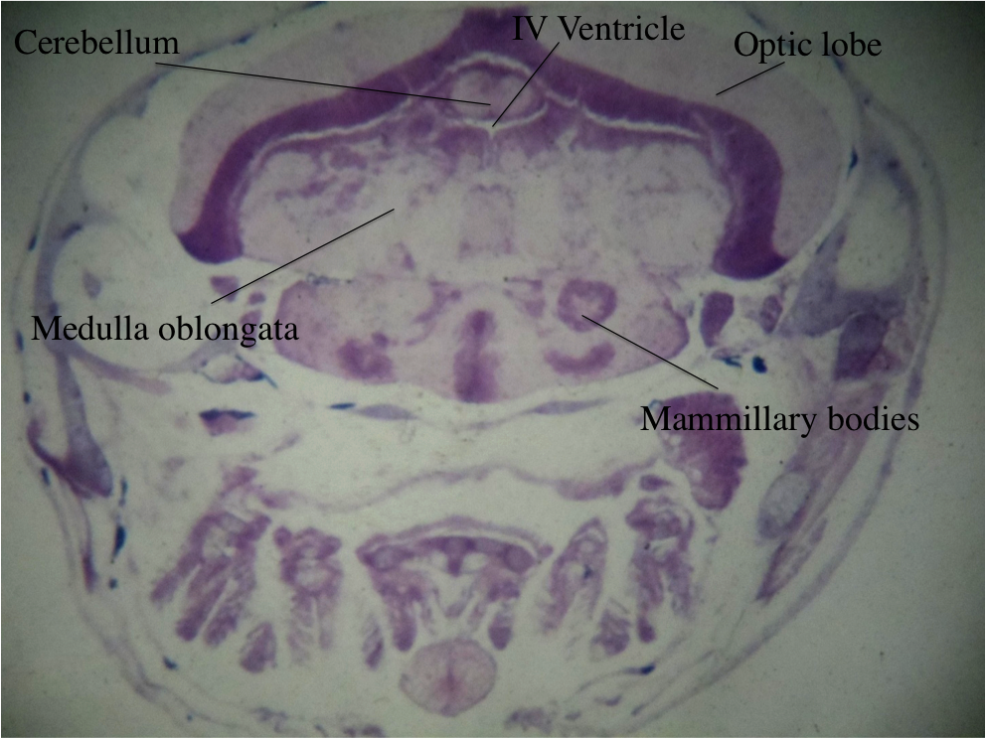
Figure 12.12. Mammillary bodies, medulla oblongata,
fourth ventricle, cerebellum, and optic lobe of the guppy.

As you follow the medulla oblongata posteriorly, the cerebellum will disappear, yet the thin roof of the wedge-shaped fourth ventricle will persist for some time. Note that, at the same time, the ventral portion of the nervous system sections are constricting. This is because the medulla oblongata of the brain has become the spinal cord. Medulla oblongata will continue dorsally, until you see the lumen that was the fourth ventricle diving centrally to become the central canal of the spinal cord (Fig. 12.13).

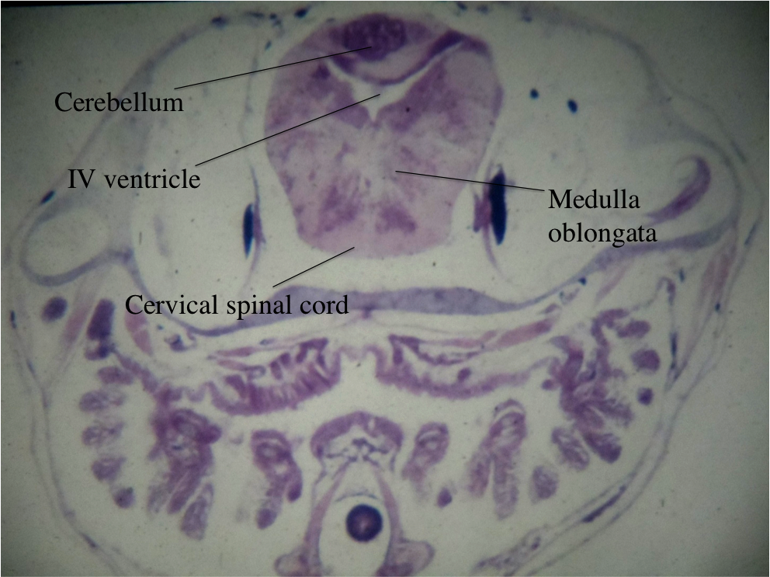
Figure 12.13. Continuation of medulla oblongata as long
as the fourth ventricle is present.
The remainder of the central nervous system is the spinal cord, which has formed once the fourth ventricle has been pinched off (Fig. 12.14). Follow it posteriorly, and note the paired spinal nerves that attach to it. Also note that the spinal cord is always immediately dorsal to the notochord (Fig. 12.14). Go anteriorly again to see where the notochord first appeared. One of the characteristics of subphylum Vertebrata is that the notochord never reaches the anterior portion of the head; thus, much of the brain develops anterodorsal to the notochord. Contrast this with amphioxus in Subphylum Cephalochordata, in which the notochord extends to the anterior tip of the organism and a brain never develops.

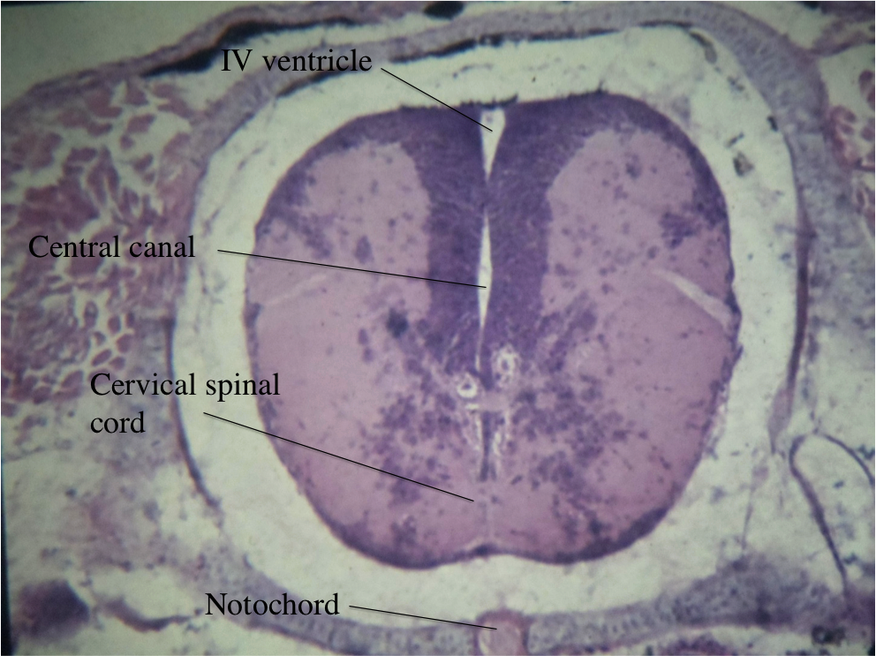

Figure 12.14. Notochord and spinal cord of the guppy.

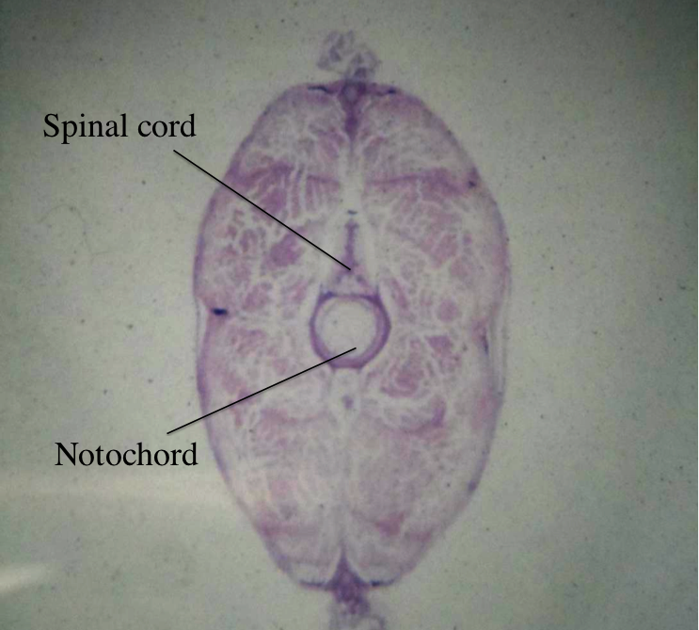
Figure 12.15. Posterior-most portion of the nervous system
in a guppy, containing only the spinal cord and notochord.
Excretory System

After you reach the spinal cord, note that ventrolaterally from the spinal cord and in the dorsal portion of the abdominal cavity are paired patches of tissue that stain heterogeneously. Each of these regions is the mesonephros of the guppy. You may have noticed these regions previously as they extend anteriorly into the region of the pharynx and posterior to the eyes. Especially the anterior portion of the excretory system in such a young guppy perhaps should still be considered a remnant of the pronephros, yet we will refer to the entire region as the mesonephros. The pronephros is the first portion of the excretory system to develop in all vertebrates; it is especially prominent in the neck. The pronephros is composed of short, convoluted pronephric tubules that empty into a pronephric duct.

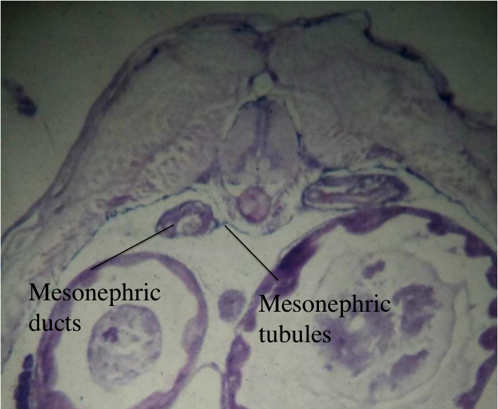

Figure 12.16. Mesonephric ducts and
mesonephric tubules of the guppy.

The pronephric duct drains the urine produced in the pronephric tubules to the cloaca. Even before the pronephros is fully formed, it begins to degenerate in all vertebrates and is replaced by a larger, posterior region called the mesonephros (Fig. 12.16). Thus, you have seen the eosinophilic, convoluted mesonephric tubules, which form horizontally in the mesonephros region. Outside these tubules is the non-tubular or parenchyma portion of the mesonephros, which has many cells with basophilic, dark nuclei. As the mesonephros replaces the pronephros, the old pronephric duct that drains each pronephros is simply renamed the mesonephric, or Wolffian duct. As you continue posteriorly in the guppy, the two mesonephric clusters of tissue will be replaced only by the paired mesonephric or Wolffian ducts. Follow these ducts posteriorly as the empty into the cloaca (Fig. 12.17).
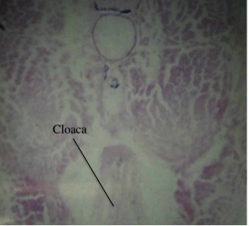
Figure 12.17. The cloaca, which is present once the mesonephric ducts have dropped and become part of the structure above.

Circulatory System

We will begin our survey of the basic circulatory system of the guppy by returning to cross-sections that are at the approximate level of the optic lobes of the brain. While viewing the guppy cross-sections, make frequent reference to the sketches in this exercise that show the basic blood vessels that comprise the circulatory system in a typical vertebrate. You should begin anterior to the heart. Note an area of skeletal muscle that crosses the ventral midline in the guppy. There should be an unpaired blood vessel, the ventral aorta, which is just dorsal to this region of muscle (Fig. 12.18). Note that all of the blood cells that you see contain a nucleus, rather than just the leukocytes as in mammals. As you move posteriorly through the guppy slides, note that the patch of muscle in the ventral midline thins, and later becomes V-shaped as you approach the heart. Concomitant with that morphological change, note that the ventral, unpaired blood vessel develops a thicker wall and drops to a more ventral location. Also note that a small space lined by a thin, black membrane surrounds the ventral blood vessel (Fig. 12.19). The thicker-walled vessel is immediately posterior to the ventral aorta, and is called the bulbus arteriosus. The space that surrounds the bulbus arteriosus is the anterior portion of the pericardial cavity. Note that the parietal pericardium stains black, which is indicative of a secretory surface as it produces pericardial fluid. The visceral pericardium must lie directly on the surface of the structures that comprise the heart; however, it does not usually stain black.
Before continuing posteriorly to the heart, note the paired blood vessels that arise from the ventral aorta and head dorsolaterally toward the gills of the pharynx. There are four pairs of these aortic arches in the guppy. Most embryonic vertebrates develop at least six pairs of aortic arches; however, some remain rudimentary, or underdeveloped and others disappear by maturity. The aortic arches are the blood supply to the paired gill arches, which give rise to the pharyngeal skeleton and musculature in the walls of the pharynx, and exist between the pharyngeal, or gill, slits.
In cross-sections of the guppy, the pharyngeal arches have a main dorsal axis from which a branched gill is suspended. The gill resembles a feather in appearance. We will break each aortic arch down into a component afferent branchial artery, a gill capillary bed, and an efferent branchial artery (Fig. 12.18). Blood flows through each of these component portions of the aortic arches between the unpaired ventral aorta and the paired dorsal aortae. In the guppy, we will use the convention that any sections of blood vessels in the gill region that are located dorsal to the ventral aorta, yet ventral to the axis of the main pharyngeal arches are afferent branchial arteries or their branches. Sections of blood vessels that are dorsal to the axis of the main pharyngeal arches, yet ventral to the lumen of the pharynx, are much rarer, and will then be efferent branchial arteries or their tributaries. We will not be able to distinguish the gill capillaries on the guppy slides.

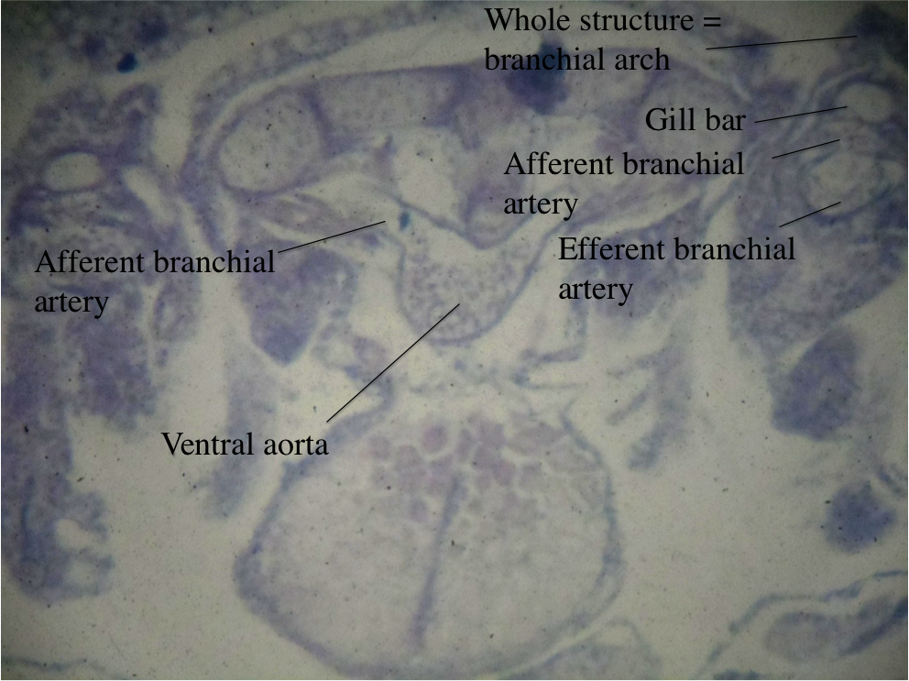

Figure 12.18. Vessels of the guppy heart. Note: the afferent and efferent branchial arteries are labeled incorrectly and should be switched.

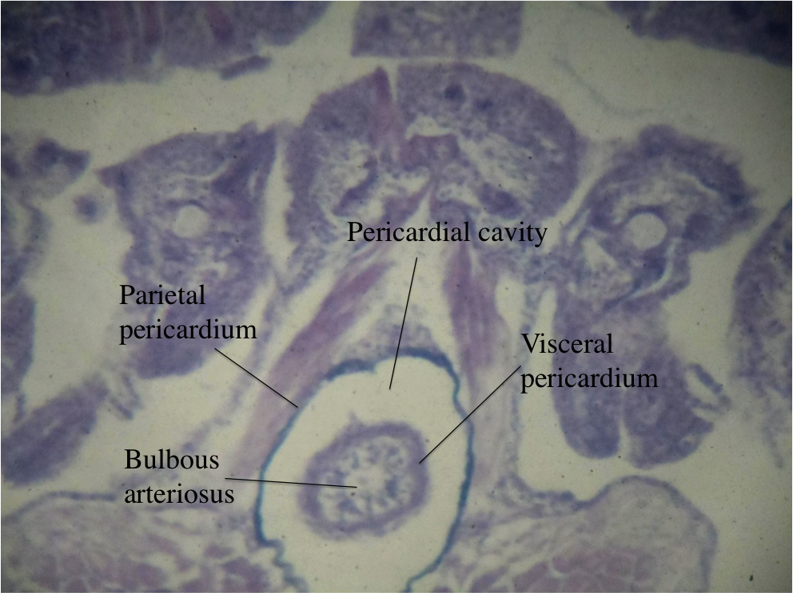
Figure 12.19. The pericardial cavity of the heart holding
the bulbus arteriosus.

Continue posteriorly to see the first true chambers of the heart. The early vertebrate heart has two chambers, a proximal, thin-walled atrium that receives blood, and a more distal, thick-walled ventricle that pumps blood away from the heart (Fig. 12.20). Refer not only to the drawing in this laboratory exercise, but also to the models of the adult perch in the laboratory to see the heart and its relationship with prominent blood vessels. The irregularly-shaped section that first appears lateral to the bulbus arteriosus should be that of the atrium. As you continue posteriorly, you will begin to see portions of the ventricle. The ventricle will be on the side of the heart opposite the atrium and has the distinction of being the most ventral chamber of the heart.
The thicker walls of the ventricle are not always clear in the guppy cross-sections. However, among the blood cells in the ventricle, note the irregular ridges of muscle that are found only in the lumen of the ventricle of the heart. These ridges are the trabeculae carnae that reinforce the walls of the ventricle. One should always look for trabeculae carnae in sections of the heart, as they are diagnostic of the ventricle, but never found in the atrium.
By this time, you have probably also contacted sections through the sinus venosus, an antechamber that is afferent to the heart proper (Fig. 12.20). Whereas the ventricle and atrium are always separated by a muscular wall, except at the atrioventricular valve, note that the sinus venosus and atrium are fully continuous. They are distinguished by the more ventral location of the atrium and the more dorsal location of the sinus venosus, which may curve dorsomedially, dorsal to the ventricle. At this time, one should be able to see the bulbus arteriosus, ventricle, atrium, and sinus venosus all in a single cross-section of the guppy.

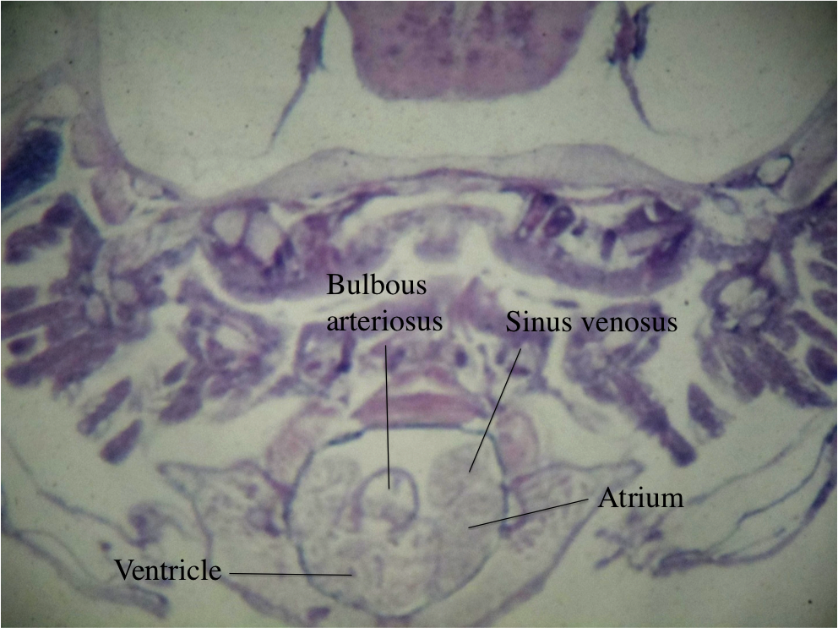

Figure 12.20. First true chambers of the heart.

As you continue posteriorly in the guppy sections, the bulbus arteriosus will disappear, followed by the heart itself. At the same time, a narrow arm will extend off of the dorsomedial aspect of the sinus venosus and reach the small mesonephros on the opposite side of the body. This is not a part of the sinus venosus, but a common cardinal vein or duct of Cuvier that empties into the sinus venosus (Fig. 12.21). On the schematic of the circulatory system in basic vertebrates (Figs. 12.29 and 12.30), note that the sinus venosus also receives a small pair of hepatic veins from the liver. We will not be able to see these vessels in our slides. In the next few sections, you will then see the other common cardinal vein or duct of Cuvier that comes from the mesonephros on the same side as the sinus venosus. In both instances, note that the common cardinal veins contact a large blood vessel adjacent to the mesonephros which is the posterior cardinal vein. Remember that you have examined the circulatory system in a direction that is backward to the direction of blood flow. Refer to the drawing of the basic vertebrate circulatory system in this exercise. Return to a cross-section through the heart. Pay attention to the cluster of mesonephric tissue that is dorsolateral to the heart. Note that a prominent blood vessel is apparent alongside the mesonephros. This vessel must be an anterior cardinal vein.
Between the mesonephric ducts and their adjacent posterior cardinal veins in the posterior region of the guppy is the unpaired dorsal aorta. Note that all of these structures are located ventral to the notochord. Follow the dorsal aorta anteriorly. As you reach the mesonephros again, note the small renal arteries that branch from the dorsal aorta and supply the mesonephros.
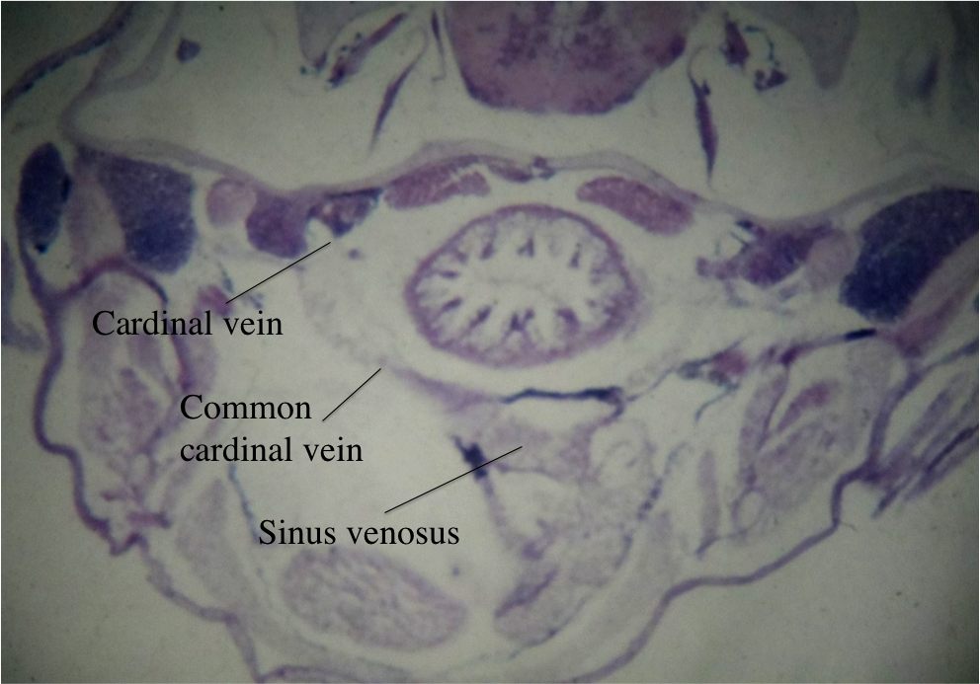

Figure 12.21. Common cardinal vein emptying into the sinus venosus.

Digestive System

Return to anterior sections of the guppy that show the brain and the gill apparatus. The gills develop in the walls of the pharynx, which is the anteriormost end of the old archenteron of any vertebrate. Remember that the presence of at least pharyngeal pouches at some point in their life is characteristic of all vertebrates. In fishes, pharyngeal grooves also form. The union of pharyngeal pouches and grooves yields the pharyngeal slits.

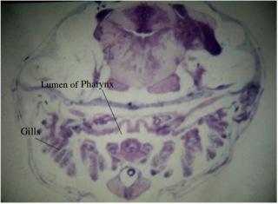

Figure 12.22. Pharynx and gills of the guppy.

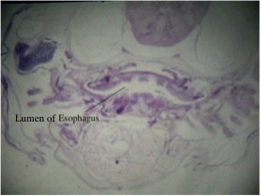

Figure 12.23. Esophagus of the guppy.

Look at the section that shows the liver prominently. In this region there should be a duct going from the dorsal part of the liver into an oval organ with a large cavity. The duct is the common bile duct, and the oval organ is the small intestine. Not far from this region, the common bile duct should be joined by a duct coming from the liver, the common hepatic duct, and one coming from a sac-like structure, the cystic duct. There is also a sac-like structure called the gall bladder (Fig. 12.24). Next, follow the small intestine anteriorly. The small intestine is lined by projections, or folds (villi), that project into the lumen (Fig. 12.24). As you go anteriorly there is a constriction in the lumen, which may or may not be recognizable.

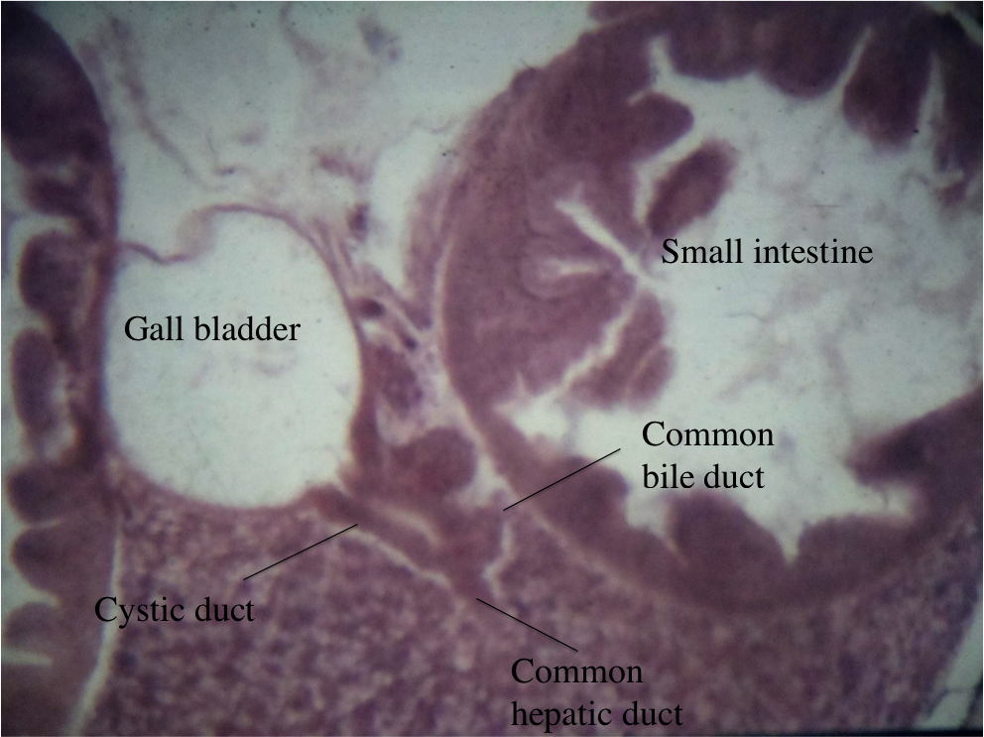
Figure 12.24. Ducts running between the small intestine,
liver and gall bladder.

In any event, the nature of the lining changes. No villi are present, and the lining is thinner and has what appear to be vacuoles in the wall. This organ is the stomach, and the vacuoles are goblet cells that secrete mucus (Fig. 12.25).

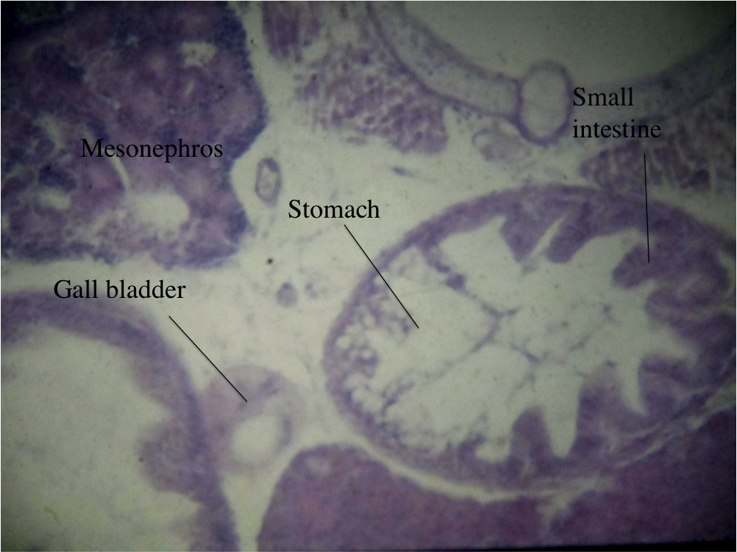

Figure 12.25. The small intestine, stomach, and
gall bladder of the guppy.

Still proceeding anteriorly, the epithelium thickens, the goblet cells disappear, and the organ goes from a circular cross-section to a mustache-shaped cross-section: esophagus (Fig. 12.23). Further anterior, the esophagus communicates with the pharynx, which has pharyngeal slits as noted previously. Anterior to the pharynx is the buccal cavity.
Return to the small intestine and follow it posteriorly. Be careful, as it loops in its course. Along the small intestine, but outside of it, there are dark patches of cells with eosinophilic centers. This is the pancreas, and it is found distributed along virtually the entire length of the small intestine. Thus, the pancreas is comprised of scattered patches of discontinuous cells, rather than a distinct organ. Eventually, the lumen of the digestive tube becomes lined by goblet cells again, similar to the stomach. This organ is the large intestine. When the goblet cells disappear, the organ is called the rectum. When the excretory system has emptied into the gut, the tube is called the cloaca. The opening to the outside is the anus.
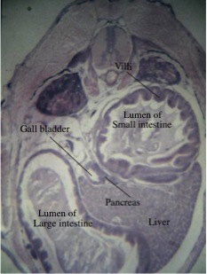

Figure 12.26. Other digestive system
organs of the guppy.

Reproductive System

Return to the section with the gall bladder, and move two or three rows anteriorly. In these sections, you will find in the peritoneal cavity, the rectum, and some pancreatic islets. Dorsal to this, there will be two clumps of a few large cells. These cells represent the ovaries. Similar, but smaller, clumps with smaller cells represent the testis in the male. You could have either a male or a female. At this stage of development, it is difficult to tell the sex. In neither sex are the reproductive ducts developed by this age.
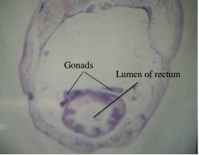

Figure 12.27. Gonads of the guppy.

Miscellaneous

In bony fish the following fins are present: paired pectoral, anterior dorsal, posterior dorsal, paired pelvic, anal, and caudal. The caudal fin is not present in these sections. Endeavor to find the others. Refer to the models for locations. The gill chamber is covered by an operculum. Water comes into the gill chamber through the mouth and pharynx.

Enigmas

Associated with the stomach should be a prominent organ, the spleen. Typically, it is surrounded by a capsule, which sends partitions into the interior of the organ. The entire organ should stain darkly. It should resemble the liver, yet be distinct from it. The spleen also should contain many blood cells, as it functions to filter the blood.

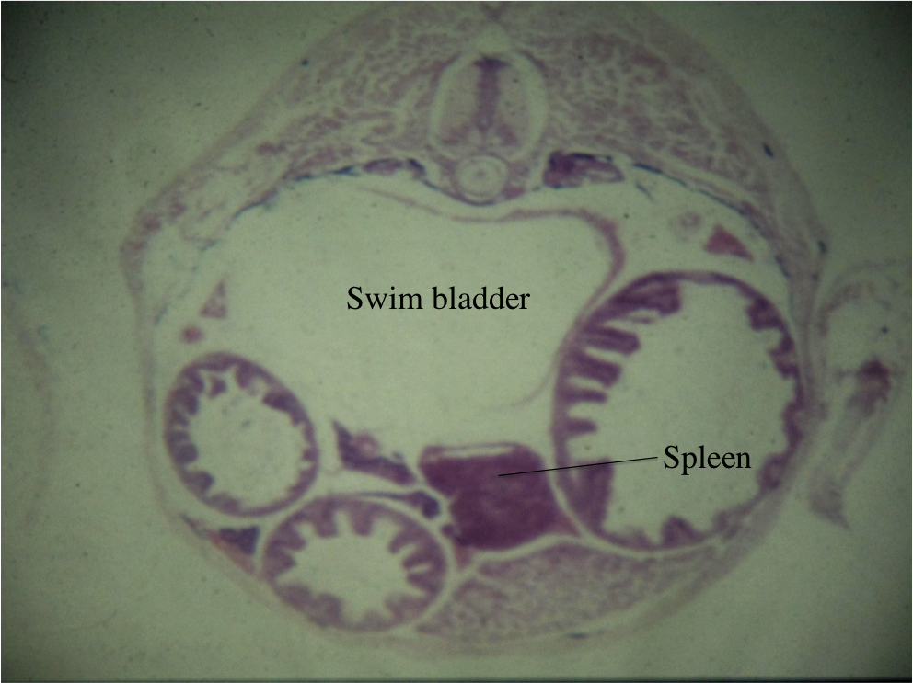

Figure 12.28. Spleen and swim bladder of the guppy.

Emerging from the spinal cord at regular intervals should be pairs of spinal nerves. The dorsal portion of these should have a swelling called a dorsal root ganglion before it fuses with the ventral member. Neither the spinal nerves nor ganglia are pronounced.
Lateral to the anterior end of the mesonephros is a mass of dark-staining tissue. The tissue would be described as lymphoid tissue. Were it adjacent to the stomach and single, we could label it the spleen. By its location it is likely that it is part of the chromaffin tissue. As described earlier, there are many cells outside the tubules of the mesonephros. These cells are the interrenal cells. In mammals, the chromaffin cells plus the interrenal cells comprise the mammals' adrenal gland.

Guppy Review

You may or may not find the following “flows” and chart (Table 12.1) of use while studying.

Nervous System

olfactory bulb $→$olfactory nerve $→$ olfactory tract $→$ olfactory lobe

eye $→$ optic nerve $→$ optic chiasm $→$optic tract $→$ optic lobe

Circulatory System

deoxygenated blood from tail $→$ posterior cardinal veins (2)$→$ common cardinal veins $→$ sinus venosus

deoxygenated blood from head $→$ anterior cardinal veins (2) $→$ common cardinal veins (2) $→$ sinus venosus

deoxygenated blood from digestive system $→$ hepatic veins (2) $→$ sinus venosus

sinus venosus $→$ atrium $→$ ventricle $→$ bulbus arteriosus$→$ ventral aorta $→$ afferent branchial arteries $→$ gill capillary beds $→$ efferent branchial arteries $→$ paired dorsal aorta $→$ single dorsal aorta $→$ body

Digestive System

mouth $→$ buccal cavity $→$ pharynx $→$ esophagus $→$ stomach $→$ small intestine $→$ large intestine $→$ rectum $→$ cloaca $→$ anus

Production of Bile

liver $→$ common hepatic duct $→$ cystic duct $→$ gall bladder $→$ cystic duct $→$
common bile duct $→$ small intestine

Excretory System

Mesonephric tubules $→$ mesonephric ducts $→$ cloaca $→$ anus
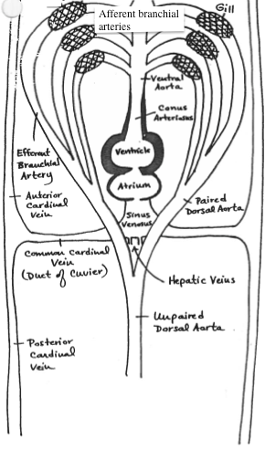

Figure 12.29. Guppy circulatory system.
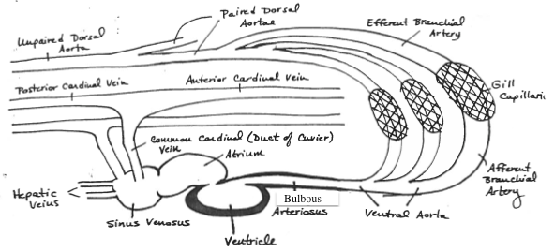

Figure 12.30. Guppy circulatory system.

